--Intermediate SQL Queries

--1.Total Revenue per Pizza Category

SELECT pizza_category, SUM(total_price) AS total_revenue

FROM pizza_sales

GROUP BY pizza_category;

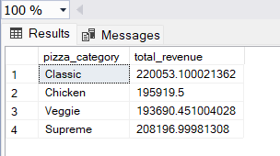

--2.Orders with Unique Pizza Names

SELECT order_id ,pizza_name

FROM pizza_sales

GROUP BY order_id,pizza_name

HAVING COUNT(DISTINCT pizza_name) = COUNT(pizza_name);

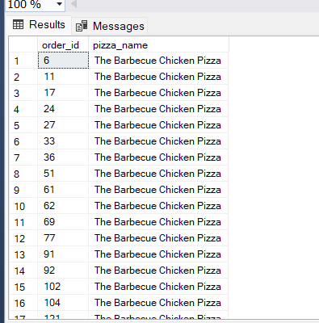

--3.Average Order Value by Pizza Size

SELECT pizza_size, AVG(total_price) AS avg_order_value

FROM pizza_sales

WHERE YEAR(order_date) = 2015

GROUP BY pizza_size;

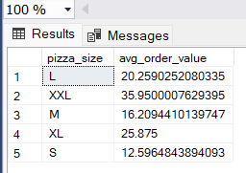

--4.Ingredient Co-Occurrence

WITH IngredientPairs AS (

SELECT i1.pizza_ingredients AS ingredient1, i2.pizza_ingredients AS ingredient2

FROM pizza_sales i1

JOIN pizza_sales i2 ON i1.order_id = i2.order_id AND i1.pizza_ingredients < i2.pizza_ingredients

)

, RankedPairs AS (

SELECT ingredient1, ingredient2, COUNT(*) AS co_occurrences,

ROW_NUMBER() OVER (ORDER BY COUNT(*) DESC) AS rownum

FROM IngredientPairs

GROUP BY ingredient1, ingredient2

)

SELECT ingredient1, ingredient2, co_occurrences

FROM RankedPairs

WHERE rownum <= 5;

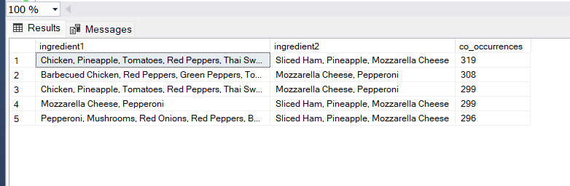

--5.Revenue Growth by Month

SELECT YEAR(order_date) AS year, MONTH(order_date) AS month,

SUM(total_price) AS monthly_revenue,

LAG(SUM(total_price)) OVER (ORDER BY YEAR(order_date), MONTH(order_date)) AS previous_month_revenue

FROM pizza_sales

WHERE YEAR(order_date) = 2015

GROUP BY YEAR(order_date), MONTH(order_date)

ORDER BY YEAR(order_date), MONTH(order_date);

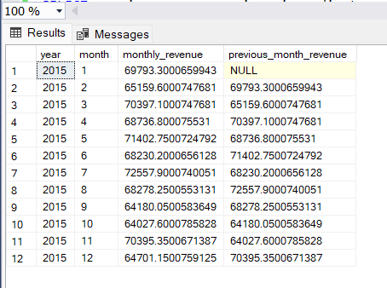

--6.pizza names and their ingredients for pizzas with a unit price above the average unit price for their respective categories

SELECT ps.pizza_name, ps.pizza_ingredients

FROM pizza_sales AS ps

INNER JOIN (

SELECT pizza_category, AVG(unit_price) AS avg_unit_price

FROM pizza_sales

GROUP BY pizza_category

) AS avg_prices

ON ps.pizza_category = avg_prices.pizza_category

WHERE ps.unit_price > avg_prices.avg_unit_price;

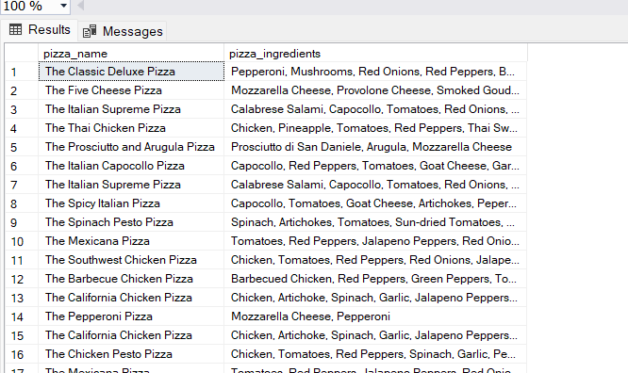

--7.Determine the percentage of pizzas category wise out of all pizzas sold

SELECT

pizza_category,

FORMAT(COUNT(*) * 100.0 / (SELECT COUNT(*) FROM pizza_sales), '0.00') AS category_percentage

FROM pizza_sales

GROUP BY pizza_category;

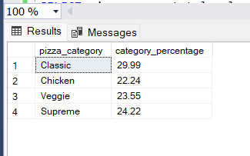

--8.List the top 10 pizza names with the highest total sales (quantity * unit price)

SELECT pizza_name, total_sales

FROM (

SELECT

pizza_name,

SUM(quantity * unit_price) AS total_sales,

ROW_NUMBER() OVER (ORDER BY SUM(quantity * unit_price) DESC) AS row_num

FROM pizza_sales

GROUP BY pizza_name

) AS ranked

WHERE row_num <= 10;

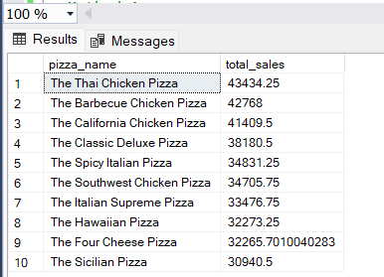

--9.Find the month with the highest total revenue

--Method 1

SELECT TOP 1

DATEPART(MONTH, order_date) AS month,

format(SUM(total_price),'0.00') AS total_revenue

FROM pizza_sales

GROUP BY DATEPART(MONTH, order_date)

ORDER BY total_revenue DESC;

--Method 2

SELECT TOP 1

DATENAME(MONTH, order_date) AS month_name,

Format(SUM(total_price),'0.00') AS total_revenue

FROM pizza_sales

GROUP BY DATENAME(MONTH, order_date)

ORDER BY total_revenue DESC;

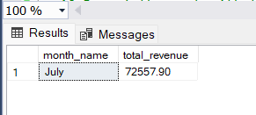

--10.Day of the week with the highest total sales

SELECT TOP 1

DATENAME(WEEKDAY, order_date) AS day_of_week,

SUM(total_price) AS total_sales

FROM pizza_sales

GROUP BY DATENAME(WEEKDAY, order_date)

ORDER BY total_sales DESC;

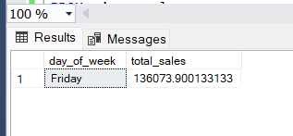

--11. Week with the highest total sales

SELECT TOP 1

DATEPART(WK, order_date) AS week_number,

SUM(total_price) AS total_sales

FROM pizza_sales

GROUP BY DATEPART(WK, order_date)

ORDER BY total_sales DESC;

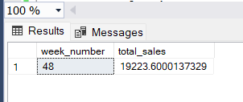

--12.pizza with the highest total price in each pizza category

WITH RankedPizzas AS (

SELECT

pizza_id,

pizza_name,

total_price,

pizza_category,

ROW_NUMBER() OVER (PARTITION BY pizza_category ORDER BY total_price DESC) AS category_rank

FROM pizza_sales

)

SELECT pizza_id, pizza_name, total_price, pizza_category

FROM RankedPizzas

WHERE category_rank = 1;

